

STANDARD OPERATING PROCEDURAL (SOP) GUIDANCE

Records Information Management for DoD Advisory Committee’s (FAC)

September 26, 2022

U.S. Department of Defense

OSD Records and Information Management (RIM) Program, Records, and Declassification Division (RDD) Washington Headquarters Services (WHS), Office of the Secretary of Defense

Table of Contents

1. Purpose: 3

2. Background: 3

3. DoD Federal Advisory Committees include but are not limited to: 3

4. Goals: 3

5. Roles and Responsibilities: 4

6. Newly Established FACAs: 5

7. Conduct a Clean Up: 5

8. Create a File Plan: 6

9. Setting up a Shared Drive: 7

10. Training: 7

11. Archiving Records: 8

**SF-258 AGREEMENT TO TRANSFER RECORDS TO THE NATIONAL ARCHIVES OF THE UNITED STATES INSTRUCTIONS: See Figure 4** 10

13. Classified National Security Information 14

OSD RIM Program Point of Contacts 15

# **1. Purpose:**

**The purpose of this SOP is:**

1. To provide new and long term Federal Advisory Committees (FACs) a standard process for incorporating OSD Records Information Management (RIM) requirements.
2. While also ensuring that Designated Federal Officers (DFOs), Alternate Designated Federal Officers (ADFOs), and committee staff understand their roles and responsibilities for creating, maintaining, and archiving Federal records.

# **2. Background:**

1. In 2005, Department of Defense Federal Advisory Committee Management Program was transferred under the purview of the Director, Administration and Management.
2. The purpose of transferring provides these committees with a single point of contact for all matters pertaining to the management of Federal advisory committees falling under the purview of the Department of Defense.
3. In prior years there had been confusion between MilDeps, OSD Components, and Defense Agencies regarding who had oversight of the FAC and which component is responsible for archiving of FAC records.

**3. DoD Federal Advisory Committees include but are not limited to:**

1. DoD- or OSD-wide Federal advisory committees established pursuant to Part 102–193 of Title 41, CFR.
2. OSD Component or OSD RIM Program-serviced DAFA committees, special study groups, task forces, boards, commissions, councils, and similar groups established to provide advice, ideas, options, and opinions to the Federal Government, established pursuant to their general Title 10, U.S.C., authorities or as directed by Congress or Federal law.
3. Interagency advisory committees established by the President of the United States, Congress, or the Secretary of Defense.
4. A DoD Component designated as the DoD Executive Agent for a DoD Federal Advisory Committee pursuant to DoDD 5101.01.

**4. Goals:**

To ensure compliance and implementation for a records information management program for any FAC IAW DoDM 5015.DF, 41 CFR Section 102-3.175, the General Records Schedule (GRS) 6.2, and the DODI 5105.4.

**5. Roles and Responsibilities:**

**a. Committee Management Secretariat, General Services Administration:** Established in 1976, per Executive Order 12024 delegated to the administrator of GSA all responsibilities of the president for implementing the Federal Advisory Committee Act (FACA). The Committee Management Secretariat operations are directed to report to the president and Congress on the activities of at least 1000 federal advisory committees.

**b. OSD Senior Agency Official for Records Management (SAORM):** The OSD SAORM has the overall responsibility for the OSD RIM program within the OSD Components OSD RIM Program serviced DAFAs and DoD Federal Advisory Committees, in accordance with Chapters 31 and 33 of Title 44, U.S.C.; Part 102-193 of Title 41, CFR; Subchapter B of Chapter XII of Title 36, CFR; OMB Circular No. A-130; and OMB/NARA Memorandum M-19-21.

**c. OSD Records Administrator**: Serves as the Federal Records Officer for RIM activities for OSD Components, OSD RIM program serviced DAFAs, and DoD Federal Advisory Committees. Oversees the implementation of RIM throughout OSD, advises the OSD SAORM on records management issues, acts as the liaison official for NARA, other government agencies, private industry, and private citizens on OSD Components, DAFAs, and FACs.

**d. Advisory Committee Management Officer (ACMO):** The ACMO shall develop and file charters for all DoD supported FACs, consult with the DoD General Council, CMS, and GSA on any matters pertaining to FACs. Oversees termination of committees, reviews and validates DoD’s submission to the annual comprehensive review and the closed or partially closed meeting report to correct any deficiencies. Develop and maintain a committee management review program to ensure that DoD and FACs comply with the appropriate statutes, Executive orders, policies, and regulations.

**e.** **OSD Records Management Analyst:** Serves as the POC for all FACs on RIM related matters. Assists individual FACs with the archiving process to NARA, the development of file plans and shared drives, develops RIM training specific to FACs, and transmits information to records personnel on RIM.

**f. Government Federal Officer (GFO):** is appointed by the DoD sponsor in writing to assist the sponsor in administrative oversight and management of their aspects of the DoD Federal Advisory Committee Management program. The GFO also serves as the liaison for the ACMO, Designated Federal Officer (DFO), Alternate Designated Federal Officer (ADFO), and the committee point of contacts.

**g. Designated Federal Officer (DFO):** Ensures compliance with any Federal rules or regulations that govern a Federal Advisory Committee. DFOs are responsible for the day to day operations of the committee and its subcommittees. They approve the agenda, approve or call the committee into meeting, attend all meetings, and can adjourn the meeting if it is in the best interest of the public.

**h. Alternate Designated Federal Officer (ADFO):** assists the DFO once appointed by the DoD sponsor.

# **6. Newly Established FACs:**

a. Personnel designated records information duties should submit their appointment letter to RDD.

b. All personnel must complete the online OSD RIM training found on iCompass at <https://whs.sp.pentagon.mil/lms/Pages/default.aspx> . In addition, personnel tasked with records management duties must take in person courses conducted by the RDD staff, see section 10 of this SOP.

c. Records personnel would need to establish a file plan for records they will be creating based on their mission, see section 8 of this SOP.

d. Records personnel will also need to create folders in a shared drive based on the records created from their file plan, see section 9 of this SOP.

**7. Conduct a Clean Up:**

1. In order to understand the records that are being created or were previously generated from a committee, records personnel should conduct a records clean up comparing the files that are on hand with the GRS 6.2 and the Records Disposition Schedule (RDS). Conducting a records clean up accomplishes two things: (1) provides organization of records whether paper or electronic (2) dispositions can be applied to records by utilizing the RDS found at <https://www.esd.whs.mil/RDD/> for records eligible to be destroyed or eligible to be archived to the National Archives and Records Administration (NARA).
2. Applying a disposition to records whether permanent or temporary will increase storage space, declutter shared drives, and allow for easy access and retrieval of records.
3. The official file number (records schedule) for a Federal Advisory Committee within the RDS is 103-06.1. The legal authority number recognized by NARA as an official records schedule is GRS 6.2, item 010 (DAA-GRS-2015-0001-0001).
4. When utilizing the RDS, records personnel are authorized to use series 100 and 200 because those are common house keeping records were all Components, FACs, and Boards, Commissions, and Tasks Forces (BCTFs) can find most of the temporary records for office use.
5. Performing key search word terms within the RDS will assist personnel in easily locating file numbers that pertain to their office. For example, in file series 100 if you put in SF 702 in the search box you will be directed to file number 101-07 “Records related to classified or controlled unclassified documents containers”.

# **8. Create a File Plan:**

1. A file plan is a one snap shot of the records your committee will be creating. It is an essential element of a compliant RIM program and is one of the key criteria that RDD will be looking for during a RIM assessment.
2. The benefit of having a file plan is, it sets up structure to organize existing and future records. It also allows records personnel to easily identify records with titles, location, classification, and dispositions.
3. There is no set template in creating a file plan but it’s easiest to create one in excel. In addition, a file plan must have key elements in order for it to be compliant. The key elements are file number, title/brief description, whether or not it is an essential record, does it have a SORN, the disposition, authority number, location, and what type of media. The classification is optional but can assist records personnel in filling out the SF 258 correctly when archiving records.

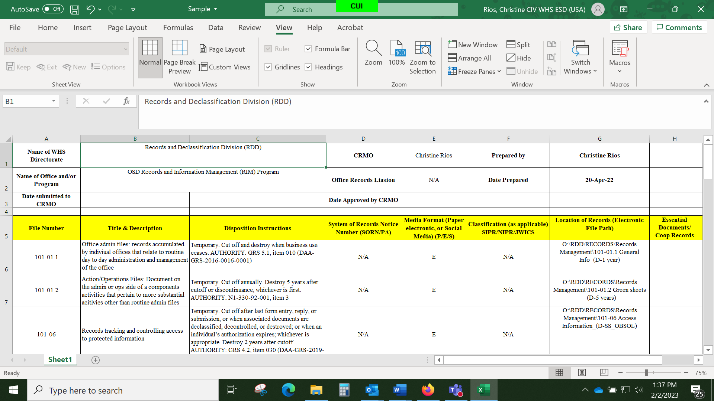

**Figure 1.**

1. Some common errors to look out for when creating a file plan. Do not list a file series, only use the file number within that series. If the disposition provides a range in time when a record is to be destroyed do not put that range on your file plan. Instead chose a date that best fits your office needs. Do not use emergency file numbers, those file numbers are permanent records and are utilized by the office conducting the emergency planning at the enterprise level.
2. A file plan can consist of a few file numbers or a dozen. It is solely based on the committee’s mission. Therefore, file numbers should not be included in a file plan if the committee is not generating those records.

# **9. Setting up a Shared Drive:**

* 1. Shared drives need to be organized in accordance with your organizations business processes.
  2. There are different ways to set up a shared drive; subject vs. file number or flat vs. hierarchical.
  3. As a FAC you will only have 3 main files to your structure; committee records (permanent), admin records (temporary), and committee management records (temporary). You can further break down these file by either CY or FY. Nomenclature of subfolders should be standardized so that files can be easily retrievable by committee personnel and for applying dispositions.

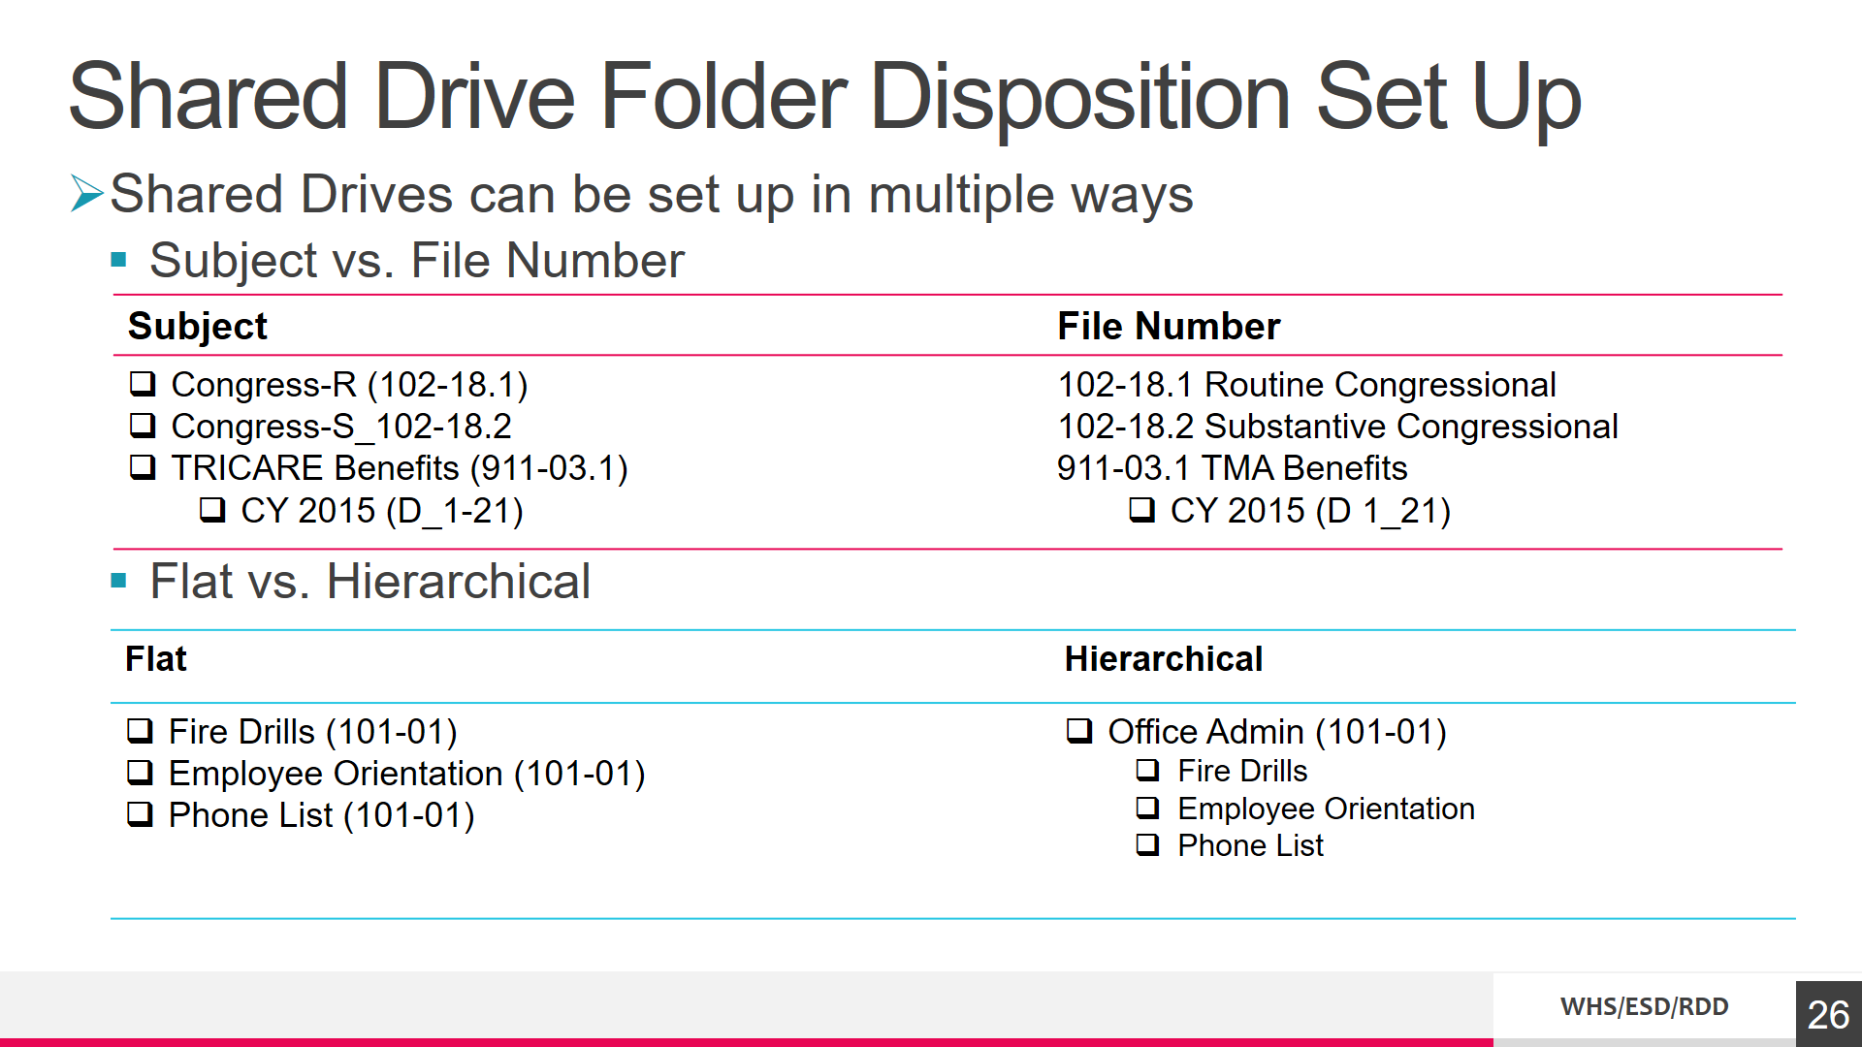

**Figure 2.**

**10.**  **Training:**

1. All personnel within OSD are required to take mandatory training on the Learning Management Site (LMS) for Annual OSD Records and Information Management Training. In addition, DFO’s, ADFO’, and RL’s are also required to take Federal Advisory Committee, Board Commissions, and Task Force Training and all 4 parts of the Component Records Management Officers (CRMO) courses through the Records and Declassification Division (RDD).
2. Personnel may sign up for courses on RDD’s share pointe site at <https://whs.sp.pentagon.mil/sites/ESD/RDD/Lists/2023%20RIM%20Training%20Sign%20Up/Public%20View.aspx>
3. If personnel do not have an @mail.mil address in their email address they will not have access to our SharePoint and therefore would need to contact the OSD RIM program staff at [whs.mc-alex.esd.mbx.records-and-declassification@mail.mil](mailto:whs.mc-alex.esd.mbx.records-and-declassification@mail.mil) to sign up for the courses. There are multiple courses records personnel can take in addition to the FAC and CRMO trainings to become well acquainted with implementing a RIM program.

**11. Archiving Records:**

1. All Committee records eligible for transfer to NARA will be processed via the OSD RIM program. Records are eligible to be transferred when they have reached 15 years of age or when the committee is disestablished.
2. There are 3 forms RDD needs in order to properly archive records;
   1. An inventory list aka a box list
   2. SF 258 <https://www.gsa.gov/Forms/TrackForm/32910>
   3. The GRS 6.2 checklist. [Link to NARA Checklist for FACAs](https://www.archives.gov/files/records-mgmt/grs/grs06-2-transfer-checklist.docx)
3. An inventory list needs to be accompanied by every accession regardless of the type of media that is being archived to NARA. Inventory lists must not have any classified titles, only go down to the folder level for identification, use easy nomenclature, and have a date range. The date range must match what is on the SF 258 field 4B. If you have numerous electronic records to organize, you can utilize NARA’s electronic accessioning tool to organize your files. This software feature allows agencies to organize, create, and streamline their file list and metadata that is required for transfer. This is the link to access the software: <https://github.com/usnationalarchives/Electronic-Records-Accessioning-Support-Tools>
4. An accession can be recalled in the future for various reasons, therefore it is imperative that the names used to identify the folders are easily understood. If a name is too vague personnel at NARA might not be able to pull it back for review. In addition, a copy of the inventory must accompany the first and last box of the accession as well as having a copy for the committee.
5. If you have any NATO records; Atomal, Cosmic, or Nato Secret you must remove them from your inventory and contact RDD to properly handle these records.
6. If the records you are archiving are eligible for transfer but have a litigation hold, you must hold on to them until the litigation case is over and is no longer required.
7. NARA can accept classified records up to SCI. However, even if your records are not classified but CUI you must still notate that on the SF 258 as well as any PII information in field 7.

|  |  |  |  |  |  |  |  |  |
| --- | --- | --- | --- | --- | --- | --- | --- | --- |
| Folder 1 |  |  |  |  |  |  |  |  |
| A | Charter 1 Jan 1981 | |  |  |  |  |  |  |
| B | Filing Letters to Congress 5 Feb 1981- 5 Feb 1994 | | | |  |  |  |  |
| C | Organization charts 4 April 1980- 15 Sept 1981 | | | |  |  |  |  |
| D | Termination Documentation 31 Oct 1995- 31 Dec 1996 | | | | |  |  |  |
| Folder 2 |  |  |  |  |  |  |  |  |
| A | Membership balance plans 15 Jan 1981- 31 Dec 1996 | | | | |  |  |  |
| B | Membership rosters 1 Jan 1981- 31 Dec 1996 | | | |  |  |  |  |
| C | Resignation letters 13 May 1987- 31 Dec 1996 | | | |  |  |  |  |
| Folder 3 |  |  |  |  |  |  |  |  |
| A | Documentation on why meetings were closed to the public 19 Sept 1981-1 Jan 1986 | | | | | | |  |
| B | Agendas 1 Jan 1981- 31 Dec 1996 | | |  |  |  |  |  |
| C | Public Comments 1 June 1981- 15 Nov 1996 | | | |  |  |  |  |
| D | Testimonies during hearing 1 June 1981-17 Oct 1994 | | | | |  |  |  |
|  |  |  |  |  |  |  |  |  |

**Figure 3. Inventory list aka Box list**

|  |  |  |  |
| --- | --- | --- | --- |
| **SF-258 AGREEMENT TO TRANSFER RECORDS TO THE NATIONAL ARCHIVES OF THE UNITED STATES INSTRUCTIONS: See Figure 4** | | | |
|  | | | |
| **FIELD** |  |  | |
| 2A. AGENCY APPROVAL | Agency Records Officer (ARO) Signature | OSD RIM program Completes | |
| 2B. NAME, TITLE, MAILING ADDRESS | Name and physical Address of ARO | OSD RIM program Completes | |
| 3A. NARA APPROVAL | NARA Transferring Officials Signature | NARA Completes | |
| 3B. NAME, TITLE, MAILING ADDRESS | Name and physical Address for NARA | NARA Completes | |
| 4A. RECORDS SERIES TITLE | Name of Committee | FACA DFO/RM Completes | |
| 4B. DATE SPAN OF SERIES |  | FACA DFO/RM Completes | |
| 5A. AGENCY OR ESTABLISHMENT | DoD Component Sponsoring Committee | FACA DFO/RM Completes | |
| 5B. AGENCY MAJOR SUBDIVISION | N/A | N/A | |
| 5C. AGENCY MINOR SUBDIVISION | N/A | N/A | |
| 5D. UNIT THAT CREATED RECORD | Name of Committee | FACA DFO/RM Completes | |
| 5E. AGENCY PERSON WITH WHOM TO CONFER ABOUT THE RECORDS | Name of FACA DFO/RM | FACA DFO/RM Completes | |
| **Note: If the committee is decommissioning this will be the POC within the OSD Records Administrator** | | | |
| 6. DISPOSITION AUTHORITY | GRS Authority for FACA |  | |
| 7. IS SECURITY CLASSIFIED INFORMATION PRESENT? | **Identify if records are classified:**   * Yes * No | **LEVEL:**   * Confidential * Secret * Top Secret | FACA DFO/RM Completes (if applicable) |
| **SPECIAL MARKINGS:**   * RD/FRD * SCI * NATO * Other | FACA DFO/RM Completes (if applicable) |
| **INFORMATION STATUS:**   * Segregated * Declassified | FACA DFO/RM Completes (if applicable) |
| 8. CURRENT LOCATION OF RECORDS | Physical location of Records: | FACA DFO/RM Completes | |
| 8A. ADDRESS | Physical Address of Records: | FACA DFO/RM Completes | |
| 8B. FRC ACCESSION | Identify the accession number if records are stored at the Federal Records Center | | |
| **Note: OSD RIM program completes if records were previously stored at an FRC by the OSD RIM program.** | | | |
| 9. PHYSICAL FORMS | **Identify form of records:**   * Paper Documents * Paper Publications * Microfilm/Microfiche * Electronic Records * Photographs Posters * Maps and Charts * Arch / Eng. Drawings * Motion/sound/Video * Other (specify): | FACA DFO/RM Completes | |
| 10. VOLUME | Volume of Paper   * (Cu. Ft.) Paper   # of Containers   * Number * Type | FACA DFO/RM Completes | |
| 11. DATE RECORDS ELIGIBLE FOR TRANSFER TO THE ARCHIVES | The date ownership of records transfers to NARA. | FACA DFO/RM Completes | |
| 12. ARE RECORDS FULLY AVAILABLE FOR PUBLIC USE? | Identify restrictions (if any) of providing the public access to this records. | FACA DFO/RM Completes | |
| **Note: See Figure 5 for types of FOIA restrictions** | | | |
| 13. ARE RECORDS SUBJECT TO THE PRIVACY ACT? | **Do the records contain PII:**   * Yes * No | FACA DFO/RM Completes | |
| 14. ATTACHMENTS | **Identify any attachments**   * Agency Manual Excerpt * Additional Description * Privacy Act Notice * Other (specify): * Listing of Records Transferred * NA from 14097 or Equivalent * Microform Inspection Report * SF(s) 135 | FACA DFO/RM Completes GRS 6.2. Checklist  <https://www.archives.gov/files/records-mgmt/grs/grs06-2-transfer-checklist.docx> | |

**Figure 4. SF 258 Instructions**

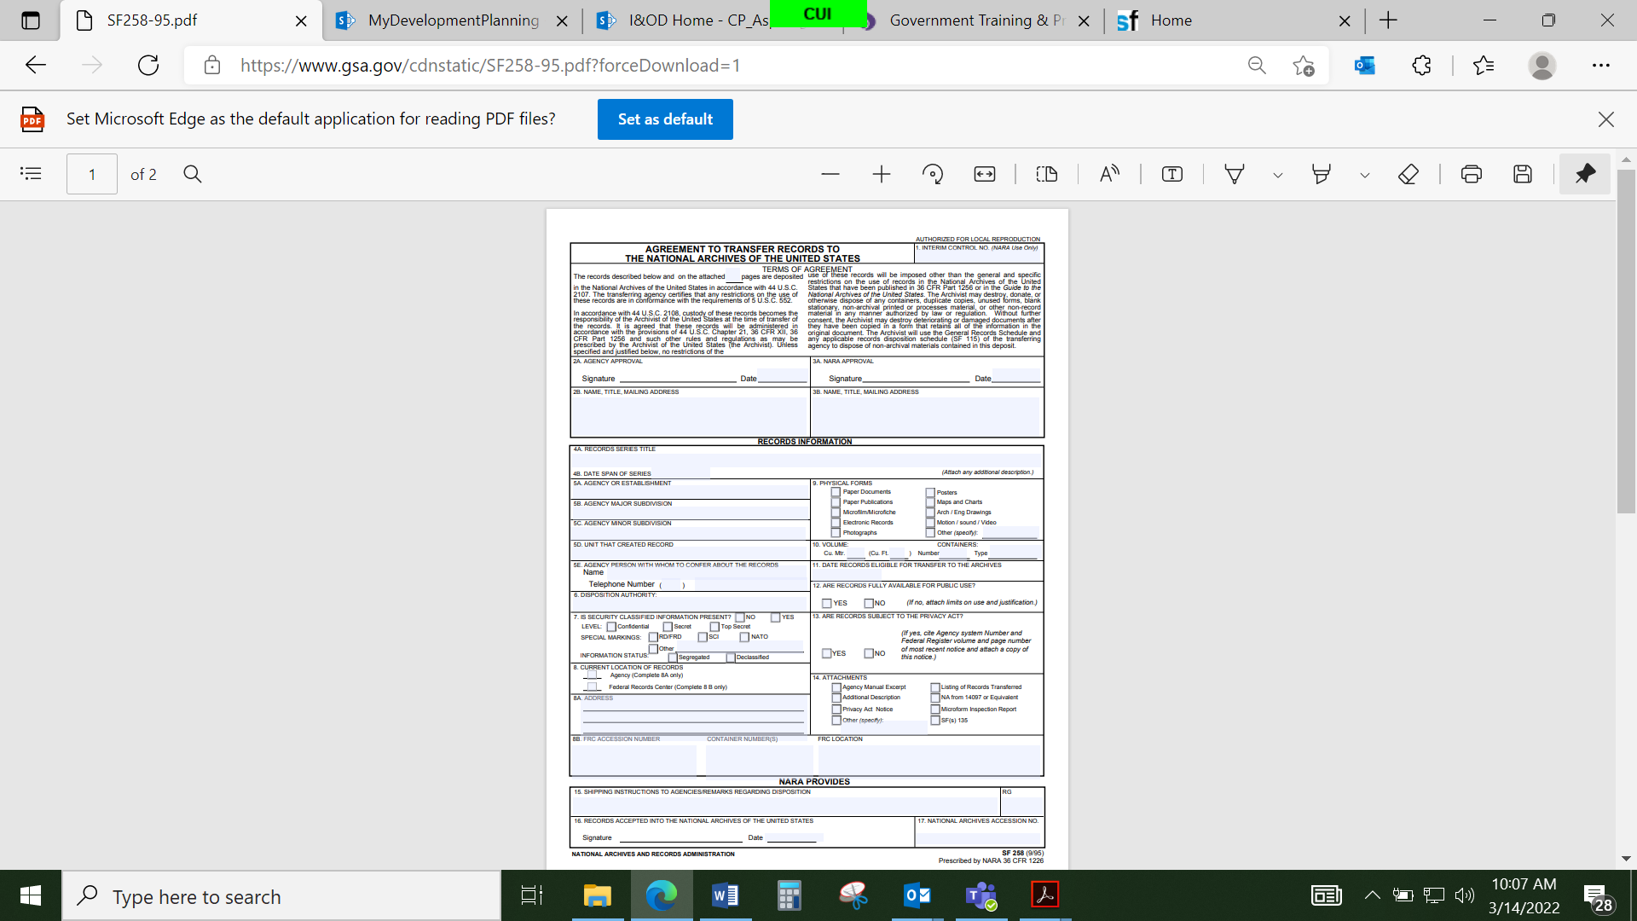

**Figure 5. SF 258**

|  |  |  |  |
| --- | --- | --- | --- |
| **Type** | **Description** | **Notes** | **Definition** |
| B1 | Classified information | Common exemption we use | Protects from disclosure of national security information concerning national defense or foreign policy. |
| B2 | Internal Matters | Only NARA can use this, do not use it | Protects disclosure records that relate to internal personnel rules and practices of the agency. |
| B3 | Information Protected by Other Statutes | Common exemption we use | Incorporates the disclosure prohibitions that are contained in other statutes. |
| B4 | Business or Trade Information | Common exemption we use | Protects trade secrets and commercial or financial information obtained from a privileged person. |
| B5 | Privileged Information |  | Protects inter-agency or inter-agency memos or letters that would not be available by law to a party in litigation with the agency. |
| B6 | Personal Privacy | Common exemption we use | Protects information in personnel, medical, or similar files that would create an unwarranted invasion of privacy. |
| B7 | Law Enforcement Records | Has further information and is broken down into 7A-7F | Applies to criminal, civil, and regulatory law enforcement records. |
| B8 | Bank Records |  | Protects information that is contained in/or related to examination, operating, or condition reports prepared by, on behalf of, or for the use of an agency responsible for the regulation or supervision of financial institutions. |
| B9 | Well Information |  | Protects geological and geophysical information and data, including maps concerning wells. |

**Figure 6. FOIA Exemptions**

# **12. Physical Transfers:**

a. Paper records – As of 30 June 2024, the National Archives and Records Administration will no longer accept paper records, per OMB Circular A-130.

b. As of 1 July 2024, Committees will be responsible for converting hard copy records to NARA approved electronic formats.

(1) NARA Tables of File Formats: https://www.archives.gov/records-mgmt/policy/transfer-guidance-tables.html

(2) Transfer Media

Committees may transfer electronic records on magnetic tape, compact disk-read only memory (CD-ROM), digital versatile disc-read only memory (DVD-ROM), external hard drive, and via file transfer protocol (FTP). Please contact our OSD RIM Program Staff to discuss other options or limitations.

**13. Classified National Security Information:**

a. Regardless of format all records containing Classified National Security Information will be transferred to the OSD RIM Program for a Kyl-Lott review per E.O 13526. **(Note: As of 30 June 2024, the Committee is responsible for converting classified paper records to electronic formats prior to transferring to the OSD RIM Program.)**

b. Upon completion of the Kyl-Lott review, the OSD RIM Program will coordinate the transfer of the records to the National Archives.

# **OSD RIM Program Point of Contacts**

* Ronald R. McCully
  + OSD Records Manager
  + WHS Records & Declassification Division
  + [ronald.r.mccully2.civ@mail.mil](mailto:ronald.r.mccully2.civ@mail.mil) (NIPR)
  + 571-372-0473 (office)
  + 703-901-3024 (mobile)
* Marybeth Weaver
* OSD Records Analyst
* WHS Records and Declassification Division
* [marybeth.e.weaver.ctr@mail.mil](mailto:marybeth.e.weaver.ctr@mail.mil) (NIPR)
* 571-372-0472 (office)
* 202-243-9546 (mobile)
* Christine Rios
* WHS/FAC Records Manager
* WHS Records and Declassification Division
* [Christine.rios3.civ@mail.mil](mailto:Christine.rios3.civ@mail.mil) (NIPR)
* 571-372-0425 (office)
* 386-801-9159 (mobile)

**OSD RIM Group Mailbox**

* whs.mc-alex.esd.mbx.records-and-declassification@mail.mil